1. **Setup**
2. Create a Django project named task_manager:



1. Create a Django app named tasks:



1. Install Django REST Framework (pip install djangorestframework):

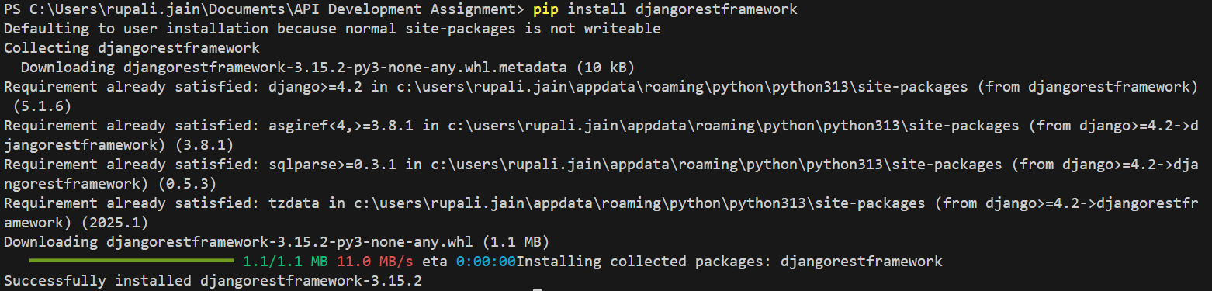

1. Add rest_framework and tasks to INSTALLED_APPS:

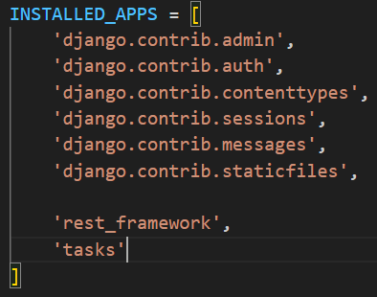

1. **Models**

Create a Task model with the following fields:

title (CharField, max_length=255)

description (TextField, optional)

status (CharField with choices: Pending, In Progress, Completed)

due_date (DateField)

created_at (DateTimeField, auto_now_add=True)

updated_at (DateTimeField, auto_now=True)

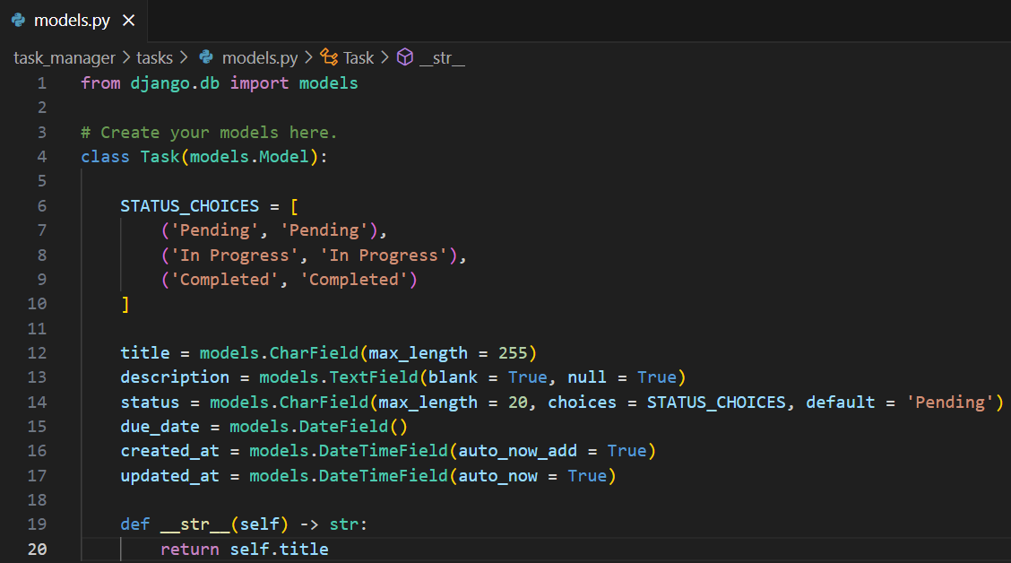

Migrating the Model:

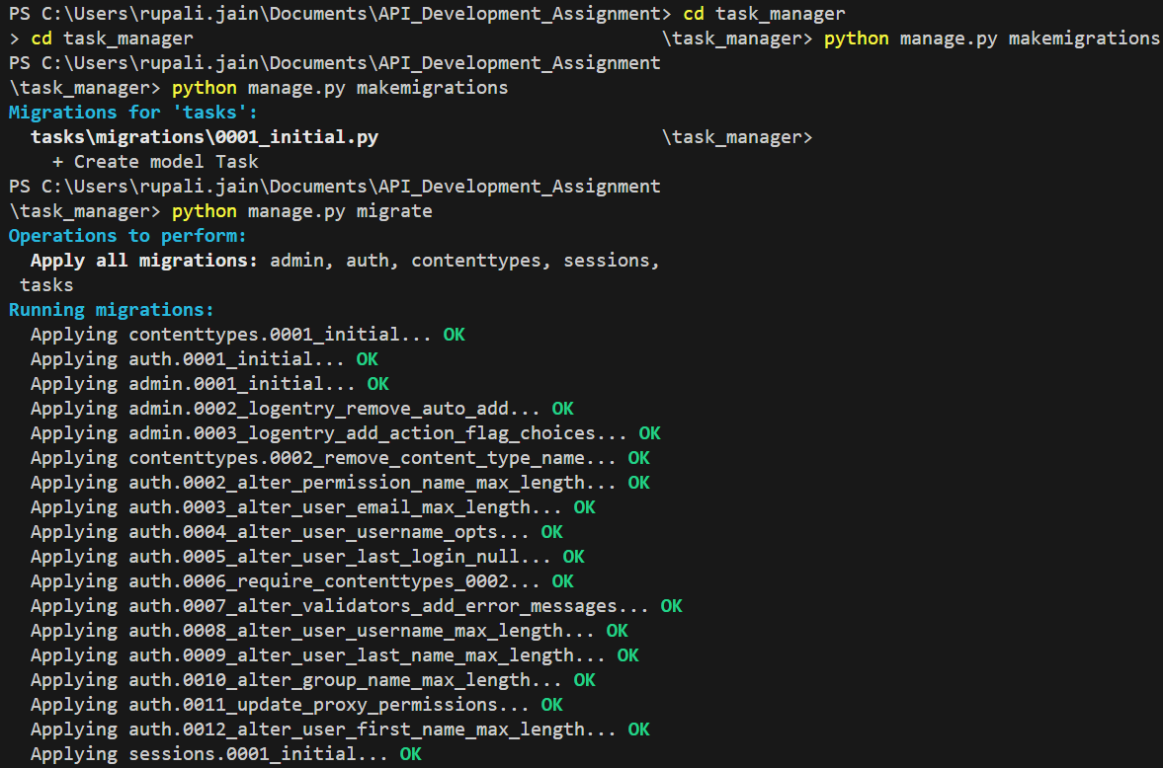

1. **API Endpoints**

Creating a task

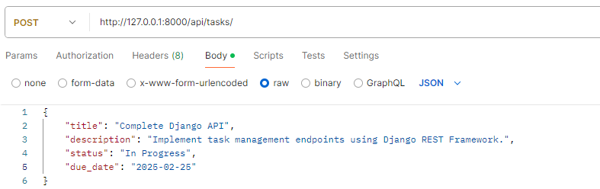

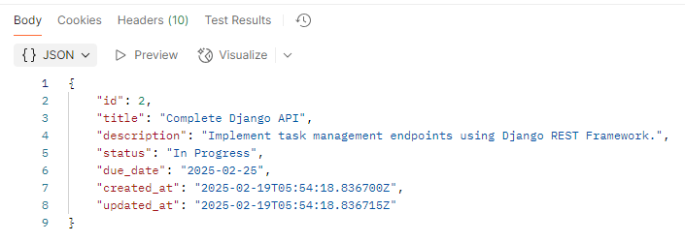

Lists all tasks

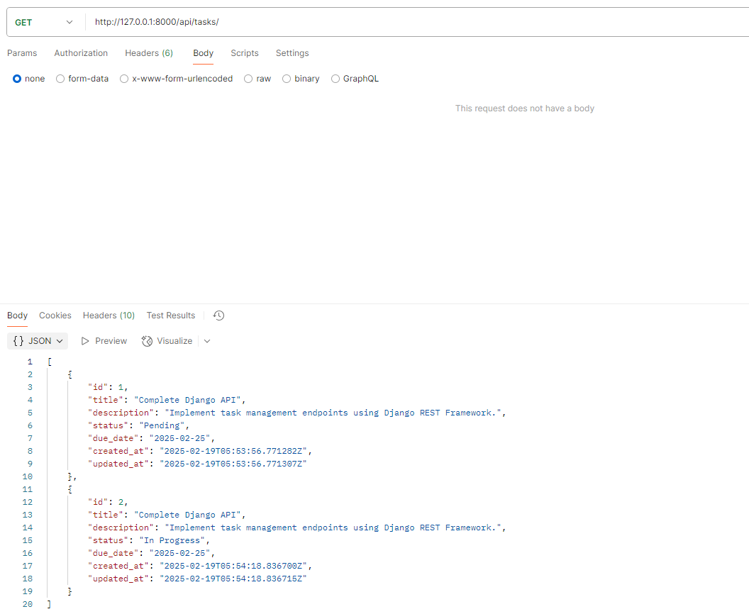

Retrieve a task by ID

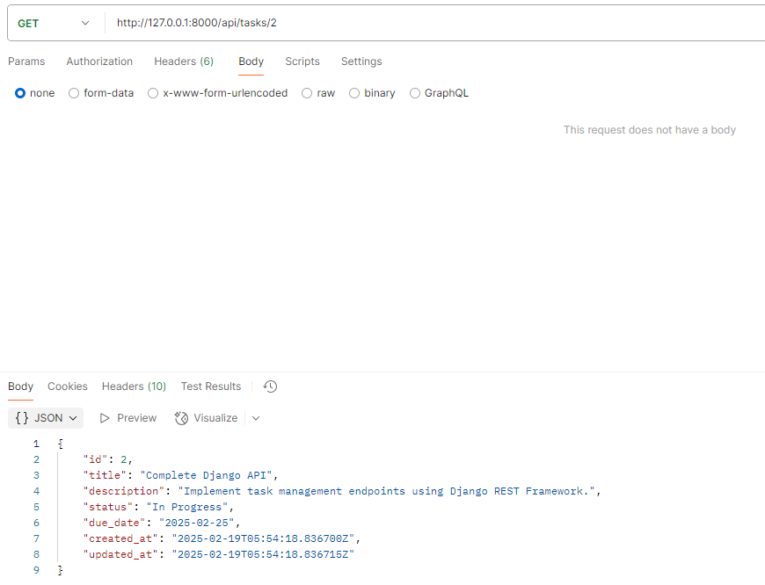

Updating a task

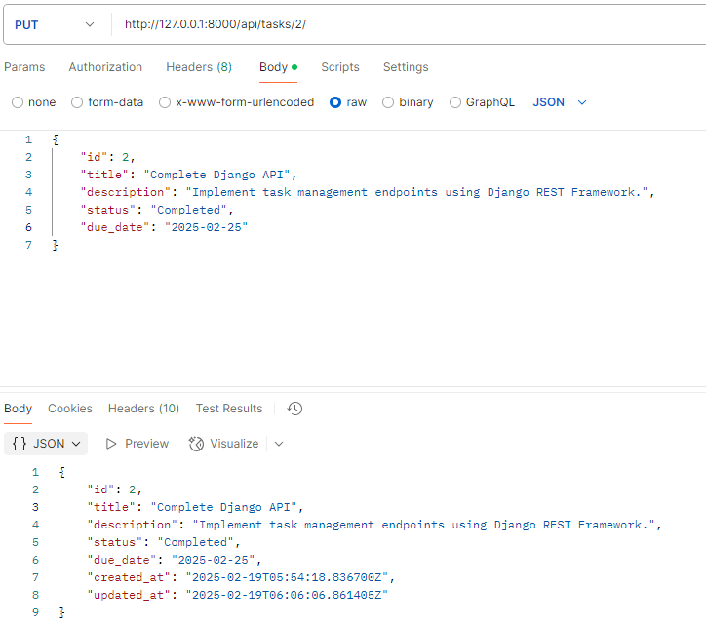

Deleted task 2

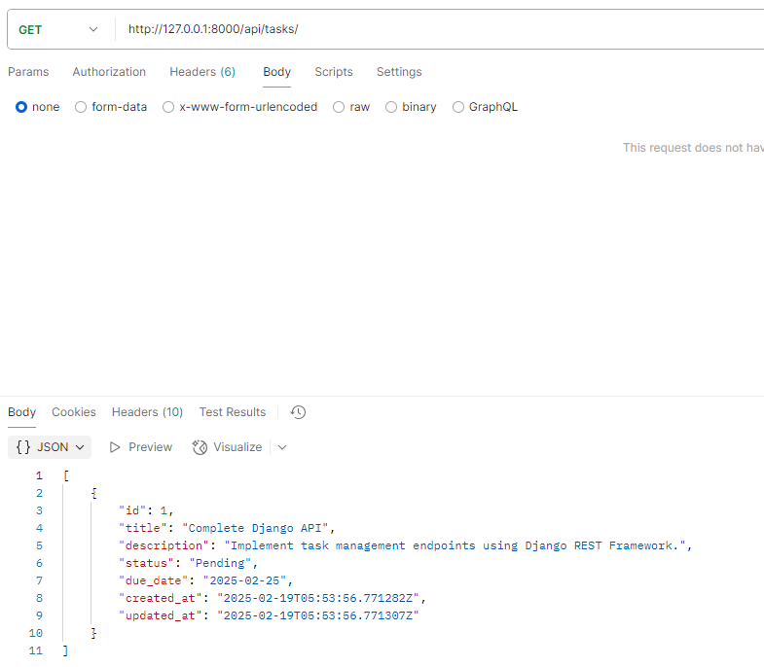

Generated a Token

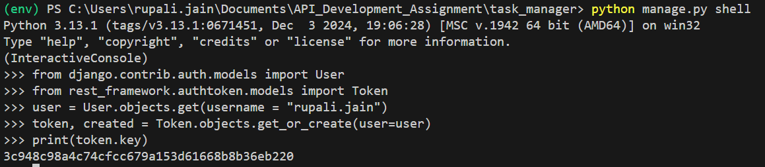

Created a super User

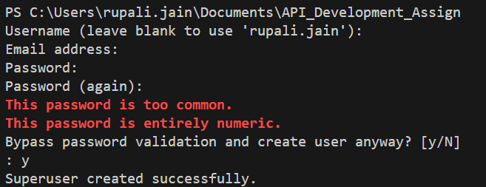

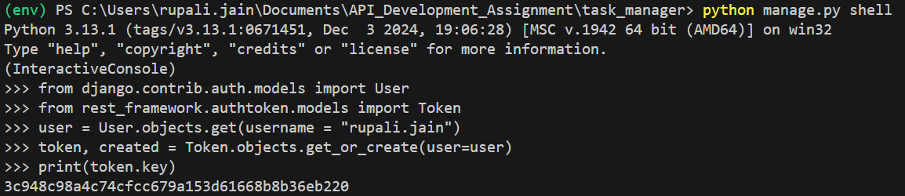

1. **Authentication & Permissions**

Updated a task with token Authentication

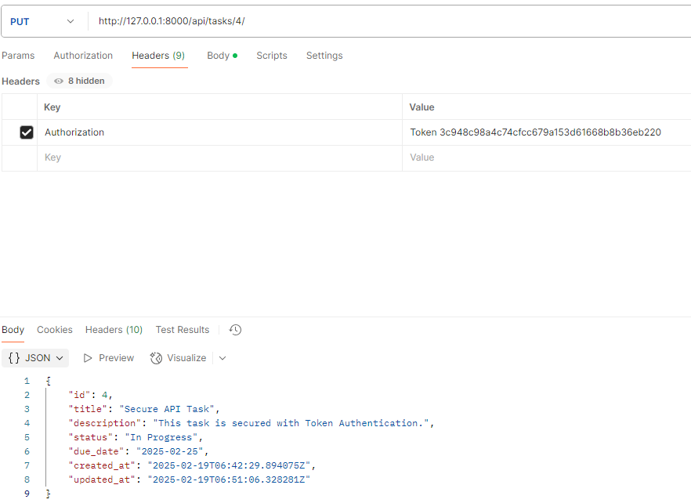

After deleting with token Authentication

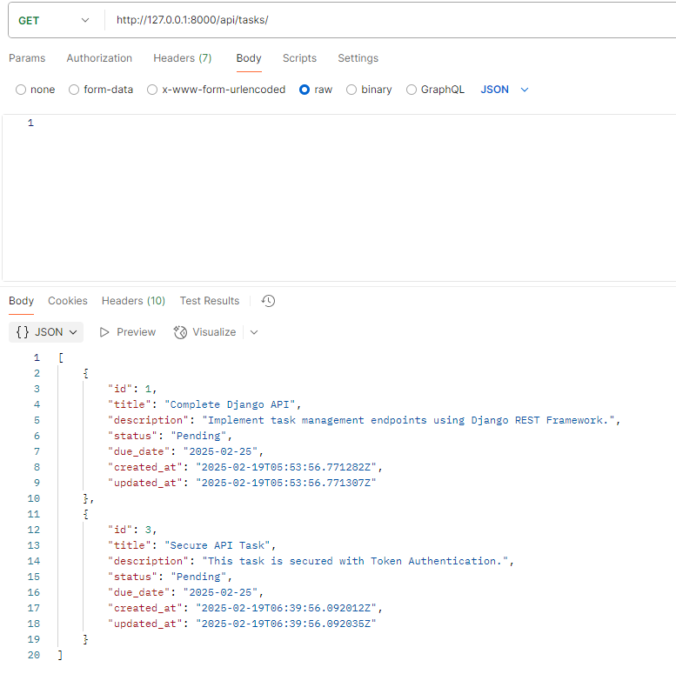

1. **Filtering & Ordering**

Implement ordering by due_date (?ordering=due_date) In ascending

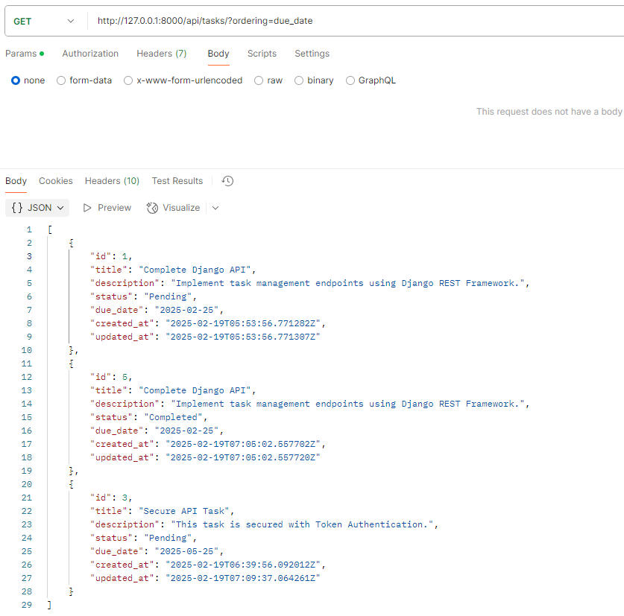

Implement ordering by due_date (?ordering=due_date) In ascending

